Week Two Assignment: Part 2
Name
Institution

Week Two Assignment: Part 2
- Job fair’s list of activities

Task # | Task Description | Estimated Number of Days
TASK One | Preparation of the checklist for the job fair which covers core components
 | List preparation | 5
 | Set up a meeting with the people in charge | 4
 | Confirm the list | 4
Task Two | Confirm the date, time and place for the job fair
 | Confirmation of event Time and date | 4
 | Identify the venue size | 4
 | Locating the venue. | 6
Task Three | Prepare the job fair budget
 | Make a list of all the required equipment | 3
 | Estimate the cost for paper suppliers, refrigerators ,and furniture | 3
 | Confirmation of the list | 3
Task Four | Advertising the job fair
 | Create the advertising plan | 3
 | create and post flyers in your area | 4
 | Invite the potential exhibitors through a letter | 4
 | Promote the job fair on various social media platforms (Twitter, Facebook, etc.) | 2
 | Post it in the newspaper. | 4
Task Five | Contact local companies, corporations organizing for the tables setups
 | Create the list of organizations in the regions | 3
 | Find the addresses and other contact information for the HR directors for every business organization, and contact them | 4
Task Six | Organizing the printing of the résumé book
 | Ask the learners to hand in the updated résumés | 40
 | Set the deadline for the submission of the resumes | 2
 | Organize as well print the resumes at the submission day | 3
Task Seven | Print signs and symbols for the job fair to direct the potential exhibitors as well as job seekers
 | Organize and print the direction signs | 4
 | Put the signs in the strategic areas | 3
Task Eight | Receive the feedback from the attendees of job fair
 | Create the survey form | 2
 | Give the job seekers the survey forms as they enter | 1
 | collect the survey forms | 1

- Create a work breakdown structure
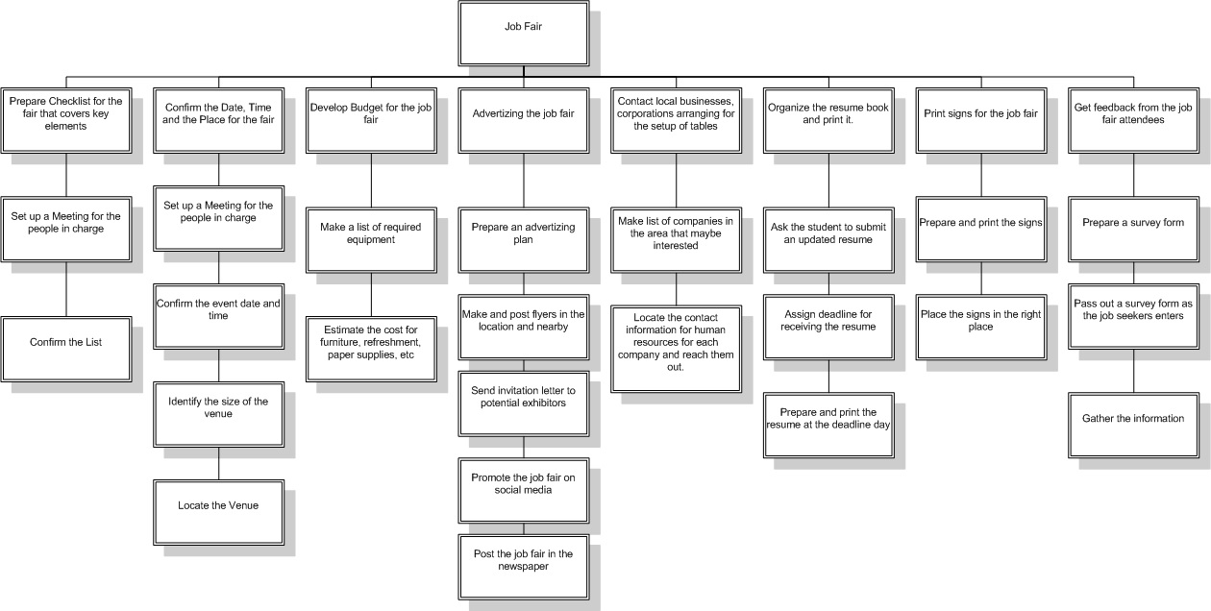
- Gantt chart proposal

